**Assignment 3**

1. **Implement transpose of a given matrix**

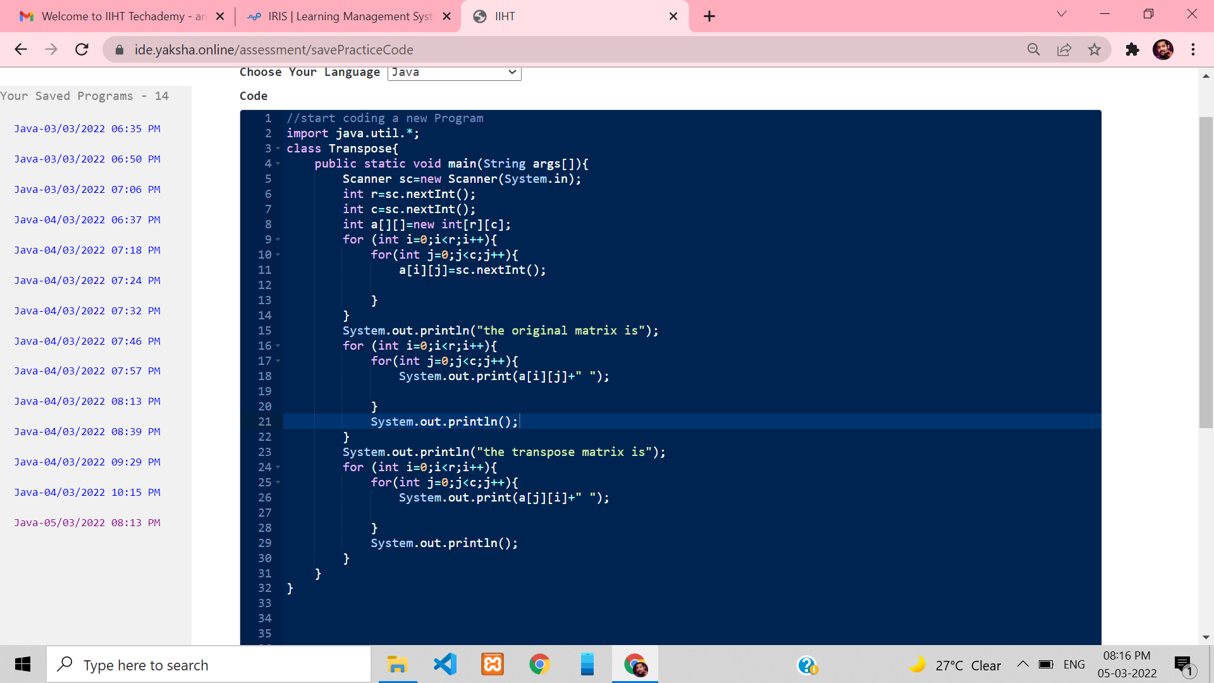

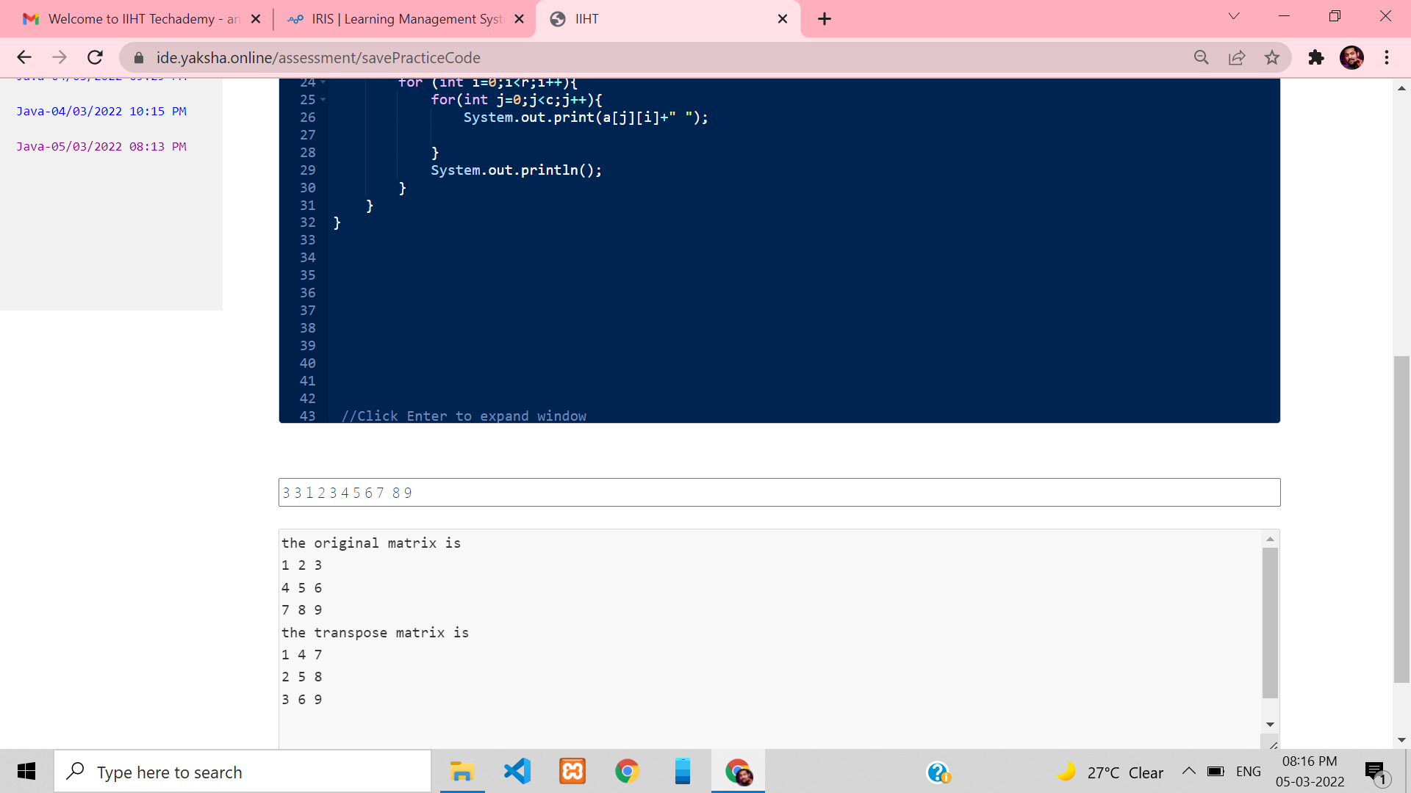

**2.** Assignment 2

Use arrays to structure the raw data and to perform data comparison & operations

Write a program which creates an integer array and displays sum of its elements.

**Implement multiplication of two Matrix**

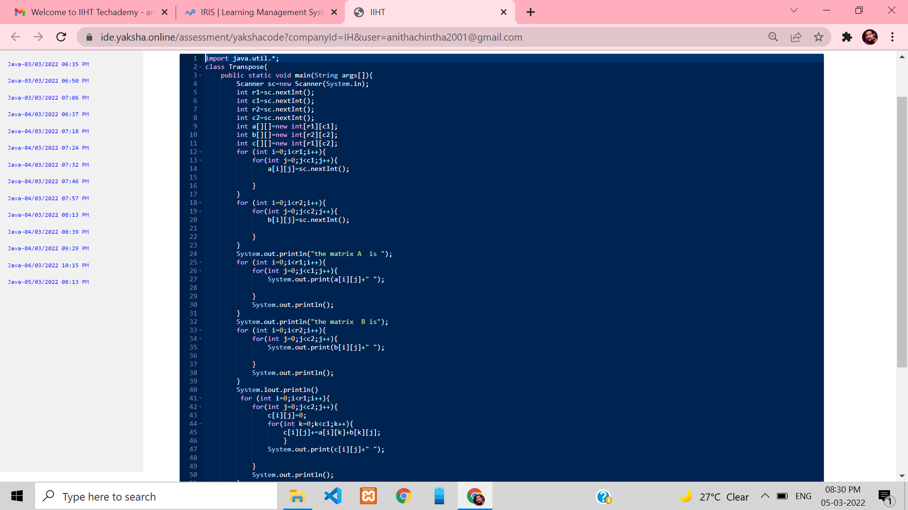

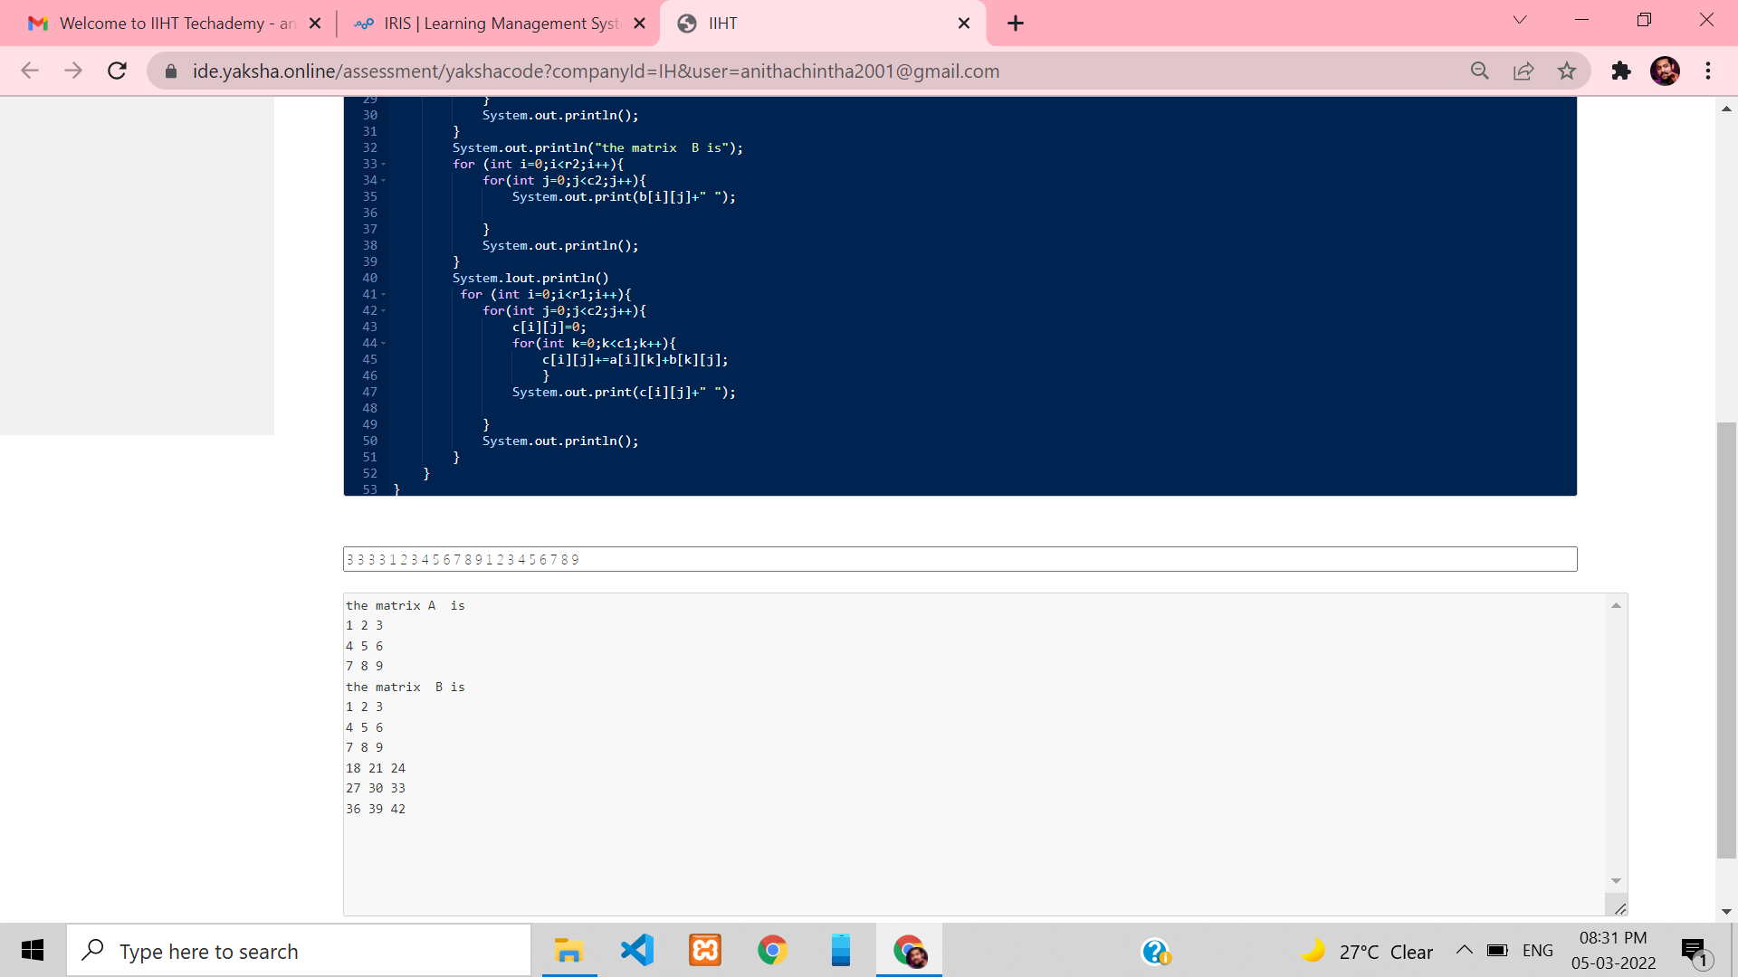

**3. Implement a program to generate random password based on**

**customer name, age and id for banking applications**

